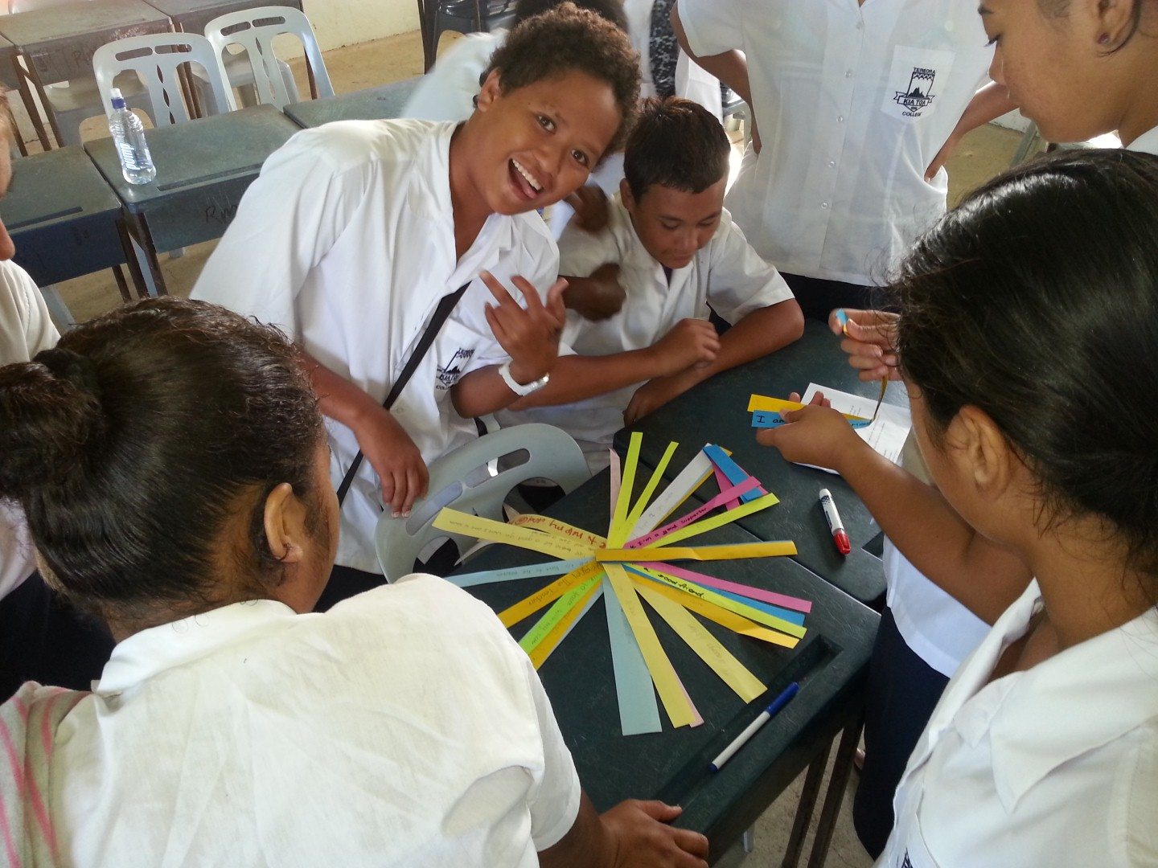
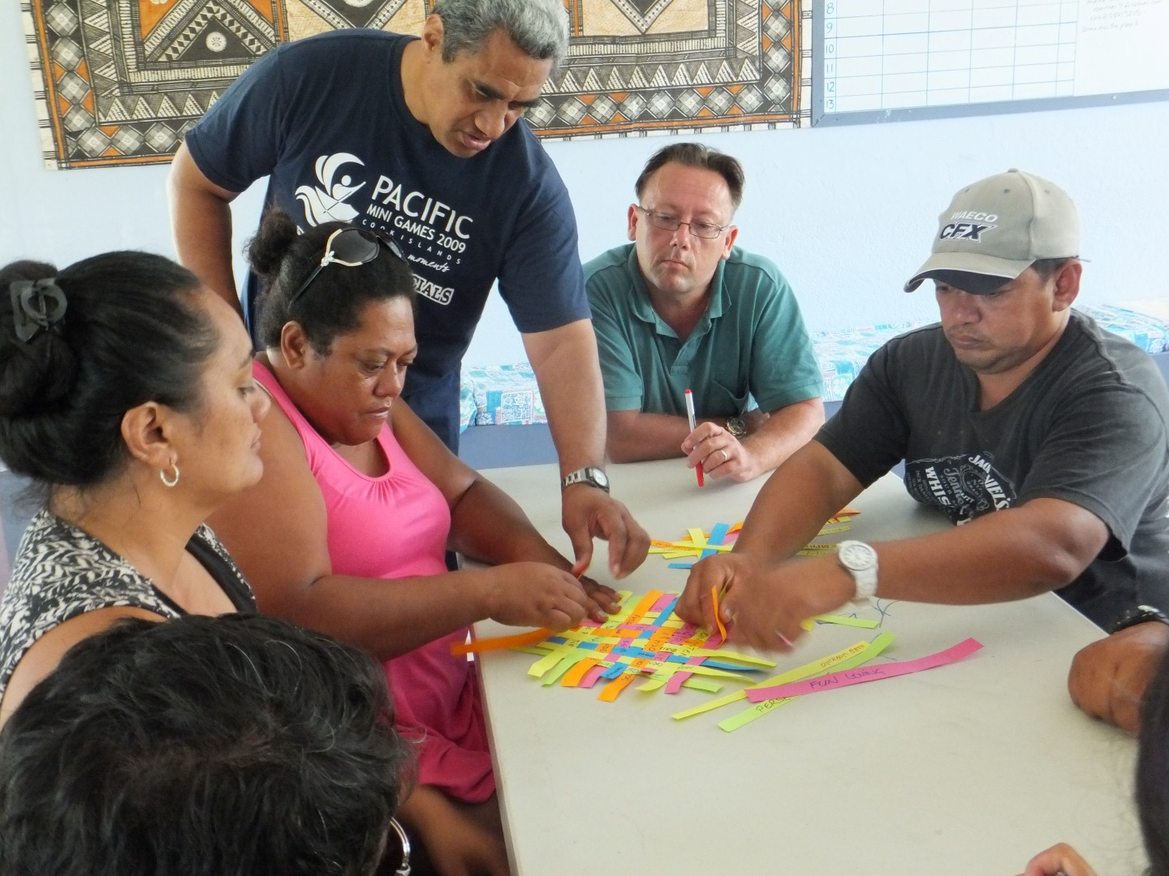
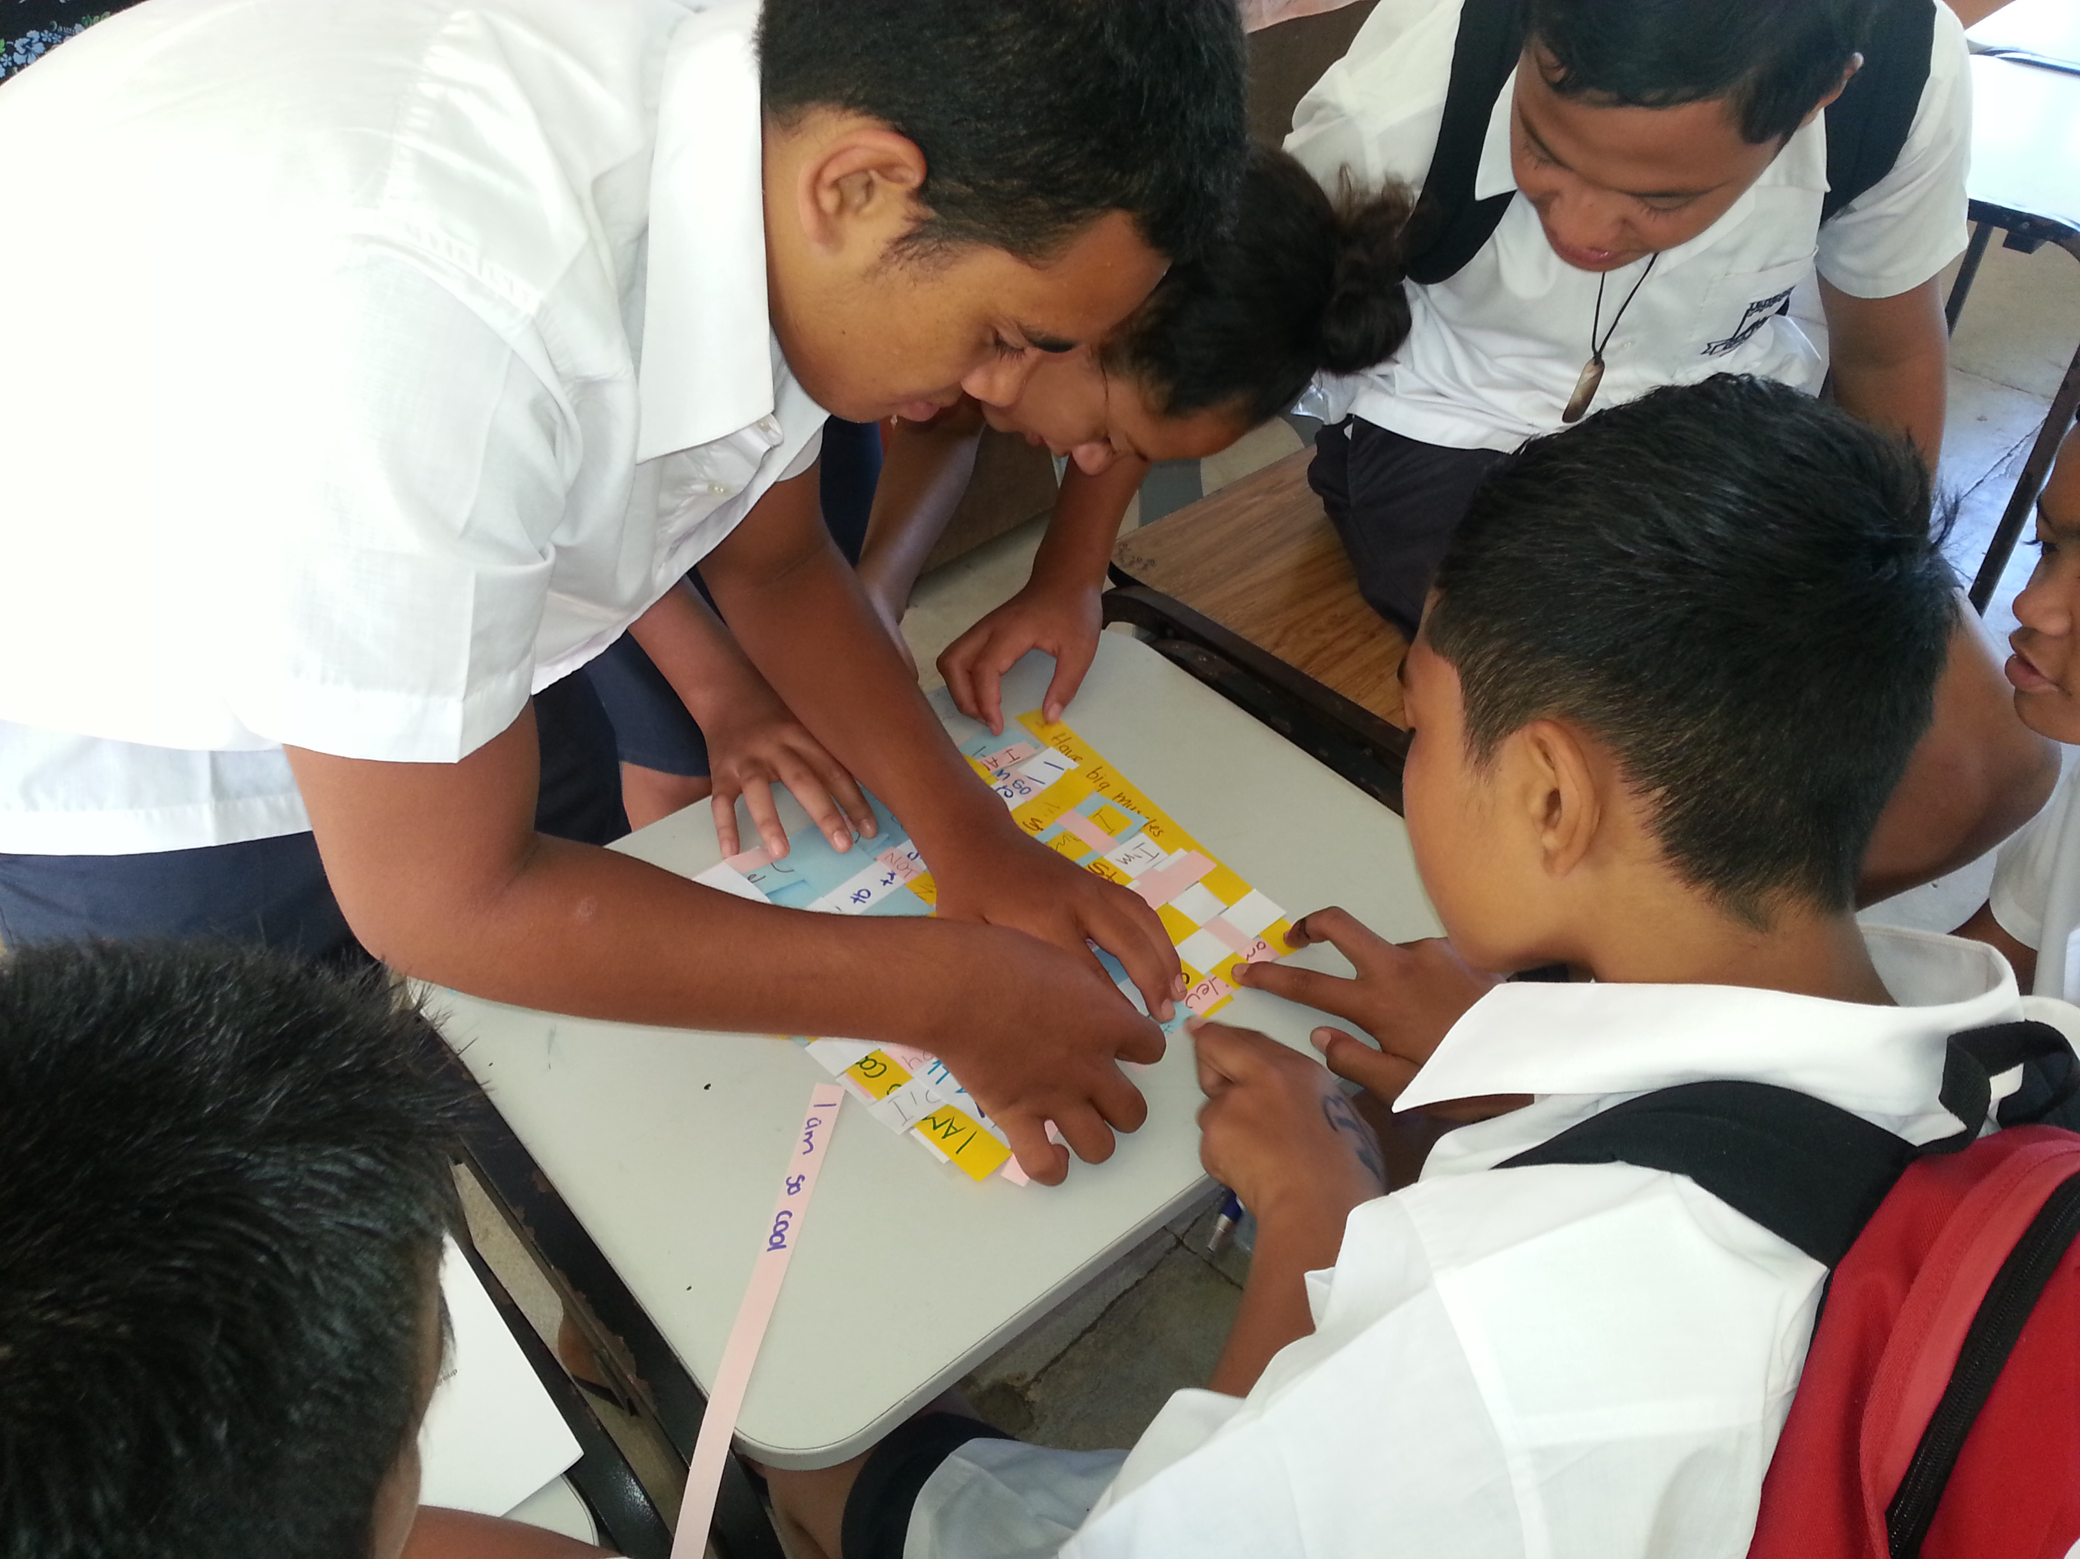
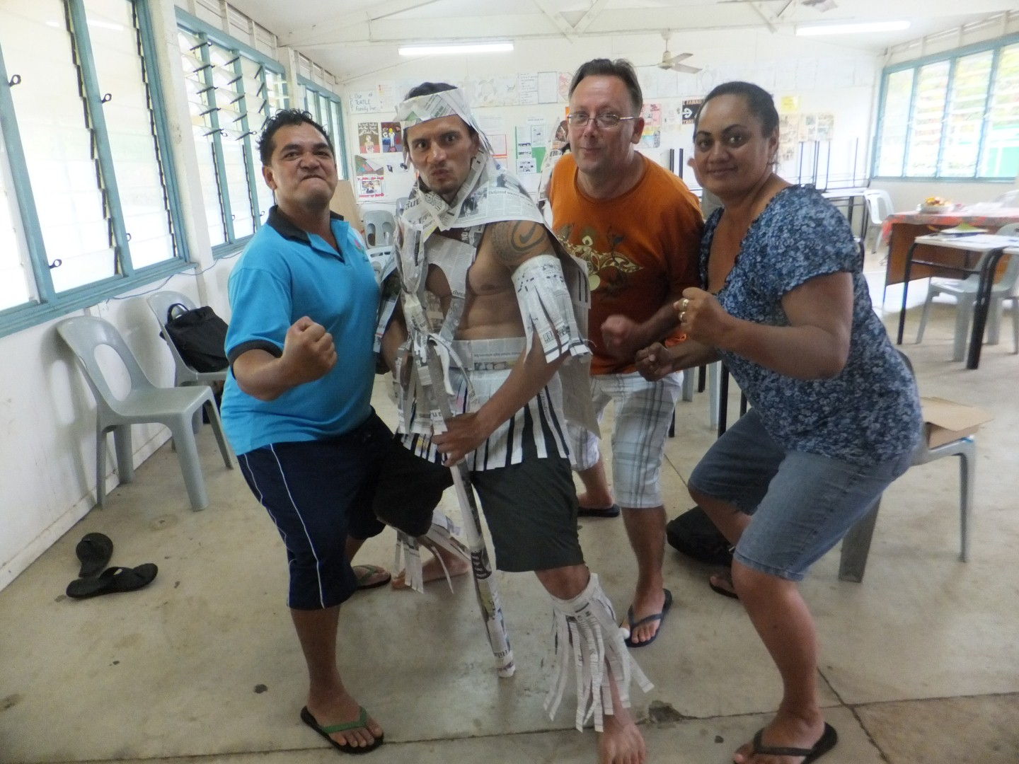
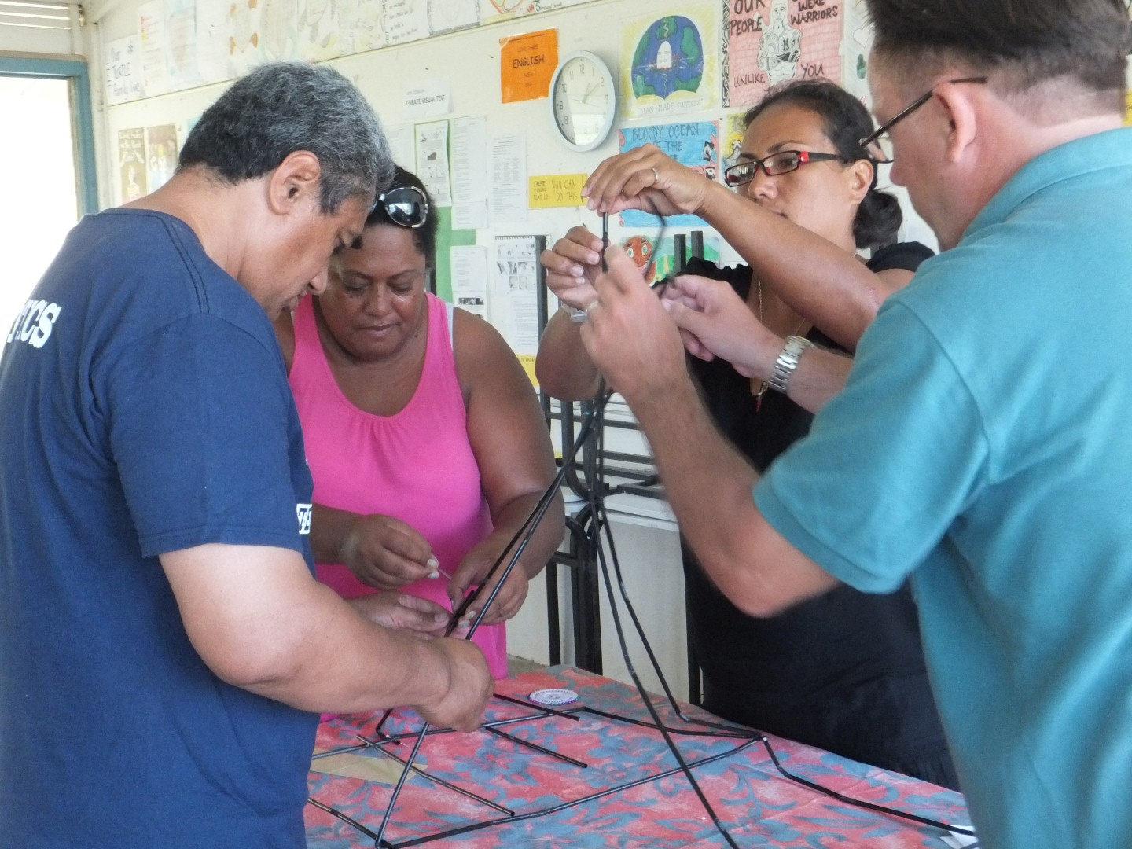
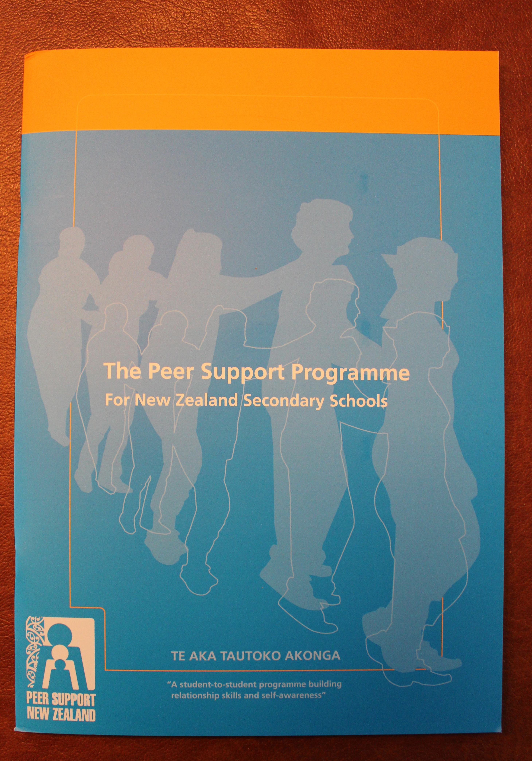
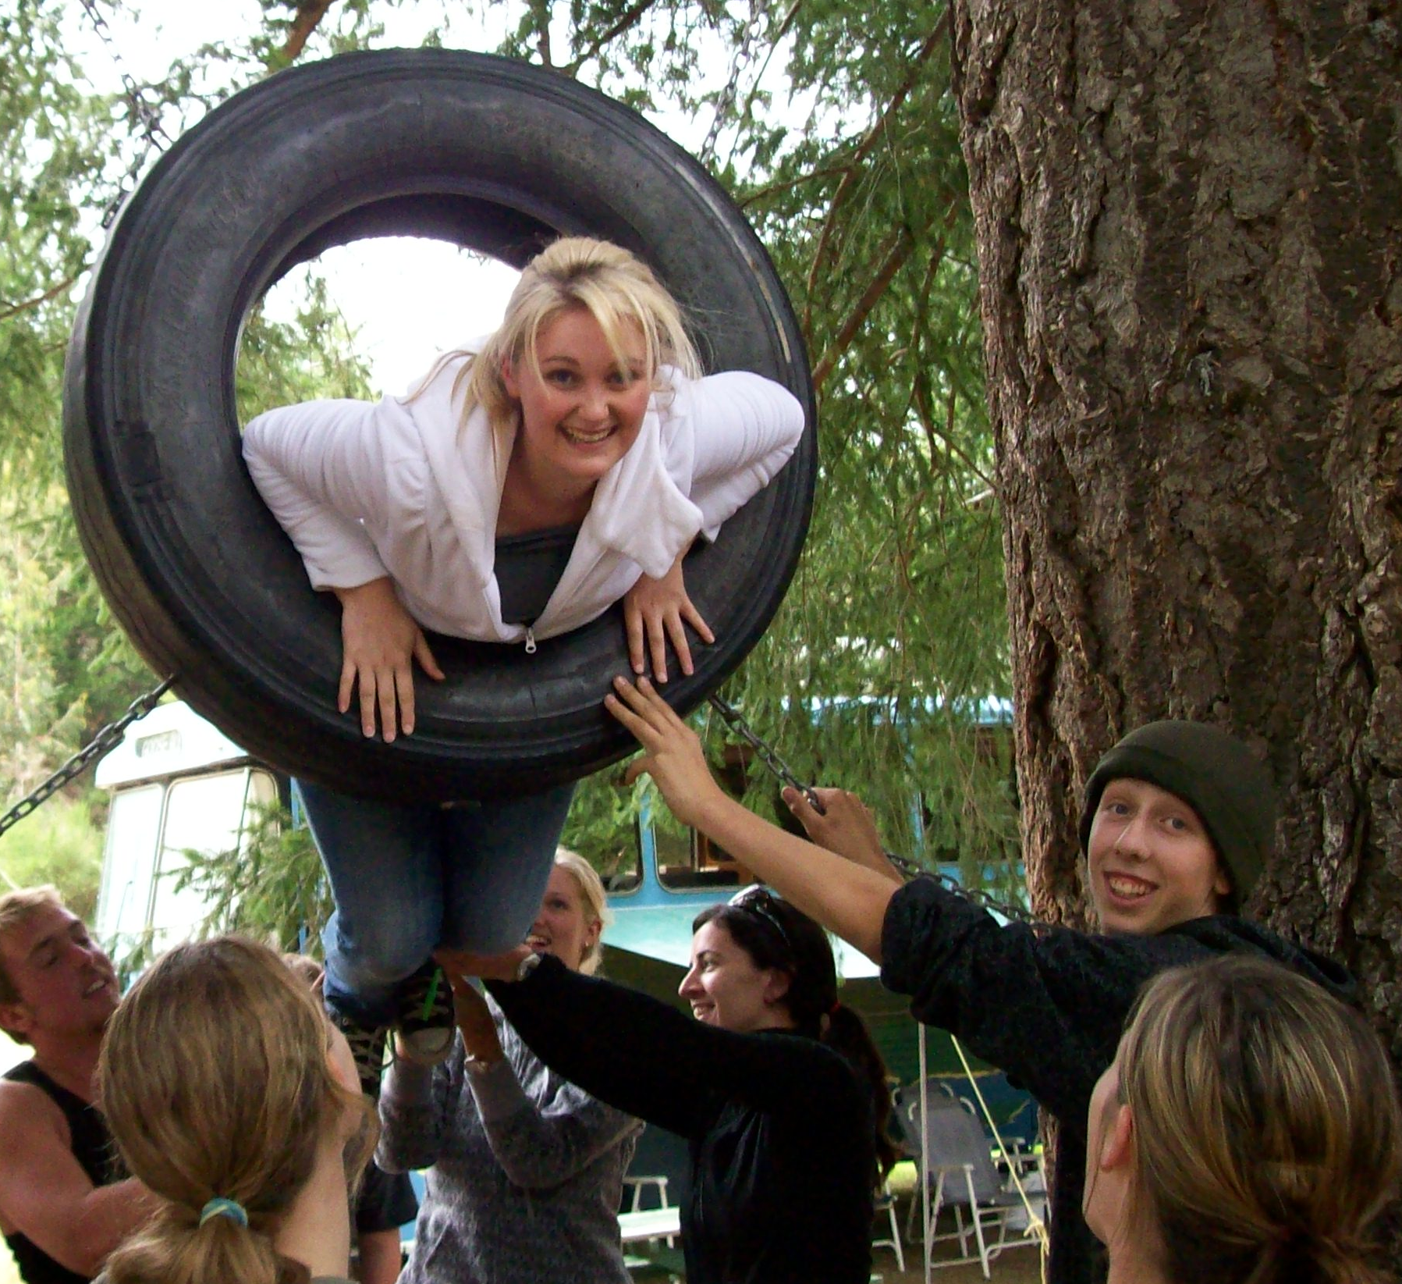
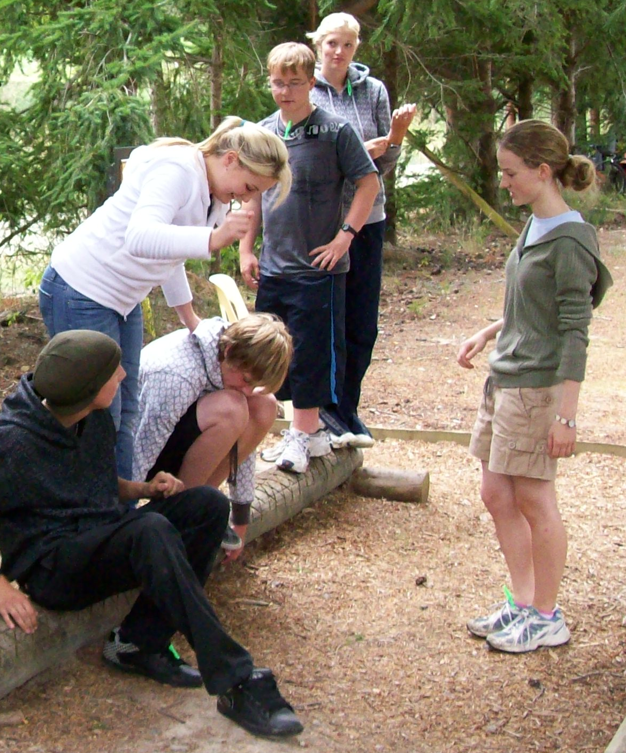
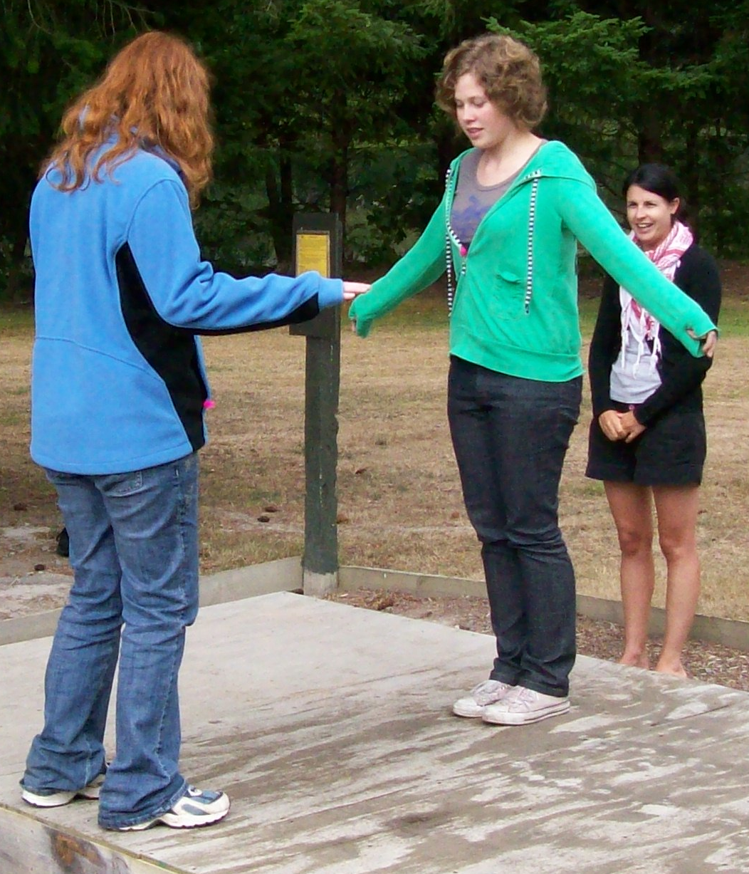
Excerpt from the Peer Leader Manual
Page 5
The new edition of the Peer Leader’s Manual

The Peer Support Programme in New Zealand
Page 4
Peer Support teacher training
Page 3
Page 1 to 2
I was given the invitation to bring the Peer Support programme to Tereora College-the biggest High School in The Cook Islands, by the principal, Bali Haque, who had been principal at Rosehill College when I had introduced the programme there One of their counsellors ,Thomas Wynne , had also worked with the programme in New Zealand and so, together ,with the fabulous support of Rotary here in NZ to expedite it,while Rotary Rarotonga came on board[as they had known nothing of the programme previously],I flew up to Rarotonga in mid-January to get the programme up and running.
“They talked about how hard it had been for them as Year 9 students especially those of them who had come from the outer Islands to come to college and knowing no-one and feeling so isolated….”

Taking Peer Support to Rarotonga – Janet Milne

Janet Milne

Pellentesque nunc odio, mattis sit amet, commodo nec, consectetuer quis, nibh.
more on 2
Contents
Janet Milne talks about introducing Peer Support to Tereora College, Rarotonga
+

September 2013
how well things were going in this first year. Bali had committed an hour for the weekly sessions which was a real testament to his belief in the value of Peer Support.
The Peer Support programme is alive and well in the Cook Islands, at Tereora College.
Janet Milne, Tutor trainer
Thomas and Nga, the other counsellor, had done a lot of preparation of resources and organisation before I had arrived-there had been much emailing and phone calling .
I trained 8 staff over 2 days-Bali had just divided the school into 4 Anau groups[House groups]-so this was perfect timing to train these 4 Anau leaders as well as the 2 counsellors, a DP, and the teacher in charge of alternative education.
We worked in the concrete floored classrooms, with the louvered windows on either side of the classroom open wide for cross ventilation and we played energisers under the trees outside in the shade, avoiding the fire ants’ nest!
It poured with rain the first day the senior students were to come in for their training, and as they walk or come on scooters we were concerned we may have a low turnout. But they came! On the second day even more came than we had been expecting-and they were so keen and fabulous. They talked about how hard it had been for them as Year 9 students-especially those of them who had come from the Outer Islands to come to college and knowing no one-or feeling so isolated.
The prefect system is very strong and very hierarchical and there was much discussion about how they wished they could have experienced Peer Support when they began their college years. I worked in a coaching role over these 2 days with the Anau leaders as they trained their students, and we also all shared morning tea and lunch together that was provided – by the generosity of Rotary Parnell.

- sodales.
college and knowing no one-or feeling so isolated .The prefect system is very strong and very hierarchical and there was much discussion about how they wished they could have experienced Peer Support when they began their college years.
I worked in a coaching role over these 2 days with the Anau leaders as they trained their students, and we also all shared morning tea and lunch together that was provided – by the generosity of Rotary Parnell.
Rotary and Peer Support also got a lot of publicity as I was interviewed for Cook Island TV and for the newspaper –and if you want fabulous accommodation look no further than the Edgewater Resort where I was lucky enough to stay as Bob Taylor ,the General Manager, is a Rotary member.
I also spoke to Rotary Rarotonga at their dinner meeting, and they were very pleased to be supporting a programme that was proactively developing the young people –both at the transition to college, and as young leaders.
Thomas has done a fantastic job of meeting weekly in the first term with all the senior students to train them for the upcoming session - he sent photos of sessions in action and was over-the-moon with how well things were going in this first year. Bali had committed an hour for the weekly sessions, which was a real testament to his belief in the value of Peer Support.
The Peer Support Programme is alive and well in the Cook Islands, at Tereora College.

The Teacher training programme
The Peer Support teacher training programme aims to equip teachers with the skills and knowledge to lead the programme in their schools. The workshop usually extends over two days and takes teachers through the full programme giving them the opportunity to try out and become familiar with may of the activities and energisers which form a basic part of the programme.
Teacher training usually occurs at the end of each year in New Zealand , usually in November. The training programme usually takes place over two days and is run by tutor trainers who are experienced in the programme and have been involved in leading the programme in their schools.
Teacher training workshops are usually held in main centre locations in Auckland, Wellington, Christchurch and Dunedin. Workshops are also held in the central North Island at a location determined by the numbers enrolling and the availability of tutor teachers. The dates and location of workshops are advertised on the Peer Support website www.peersupport.org.nz and in the Education Gazette around August/September each year. The cost of these workshops varies between $100 and $200.
For information about teacher training courses go to www.peersupport.org.nz/for+teachers

Teacher training programmes
Training teachers to support and lead the peer support prpgramme in their schools is a big part of the Peer Support Trust’s programme each year.

The Peer Leader’s Manual – a new edition
The new edition of the Peer Leader manual is the work of a group of teachers who are experienced tutor-trainers. The group consisted of Dee Doherty, Barbara Freeman, Natasha Marshall, Margaret Flanagan, Ray Sheppard and Karen Volweiller and as led by the Peer Support Trust chairman, Peter Allen.
The revision work began with a workshop in Wellington during July 2010. The core of the peer support programme has been retained based around the fourteen sessions or modules which make up the programme. Links have been made with the New Zealand Curriculum for each of the modules and the key competencies relevant to each module have been identified. Activities have been revised and added and the energisers which are used to start and finish sessions have been revised and new energisers have been included.
The Peer Support programme remains as relevant to schools and students as it did when it was first introduced into New Zealand over 30 years ago. As publisher of the manual, the New Zealand Peer Support Trust acknowledges and thanks all those who have contributed over the years to the evolution of the Peer Support Programme as expressed in the manual. The Trust also acknowledges the support in the form of a grant received from the Keith Laugesen Trust based in Christchurch which has helped with the costs of printing. the

STOP PRESS !!

The new edition of the Peer Leader’s Manual is now available for purchase at $16 (inc GST)
+
An extract from the revised Peer Leader Manual: Session starters and energisers
The way each session begins is important. What is said and done can set the mood for the session, help the group to settle to their task and focus their thinking. Session starters and energisers are used to help with this.
Energisers that work early in the programme:
Self Portrait
This is a good activity with strangers.
Draw a picture of yourself and four things about you. Put the drawings upon a wall.
Over time (maybe leave the pictures in place for a week before revealing who is who), students guess which pictures match which members of the group/class.
Trains and Stations
The group stands in a circle. One person from the group is sent from the room.
Two people are selected to be ‘stations’. They say “toot-toot”.
Two people are selected to be ‘crossings’. They say “ding-a-ling”.
The train leaves the station by squeezing the hand of the neighbor who must send it on within 2 seconds. Only stations can change the direction of the train.
The person sent out of the room is brought back in. They are in the middle and it is their job to try and catch the train. They don’t know who are ‘stations’ and who are ‘crossings’. They have to try and detect who are ‘stations’.
Picknicking
Ask the students to sit in a circle,
Ask one student to begin by saying their name and an item they will bring to the picnic – the item must start with the same letter as the student’s name e.g. “I’m Jo and I’ll bring jam…”
The next student in the circle repeats the information already given and adds their own name and item e.g. “Jo will bring jam and I’m Frances and I’ll bring fish….”
The task becomes more complex as the items accumulate.

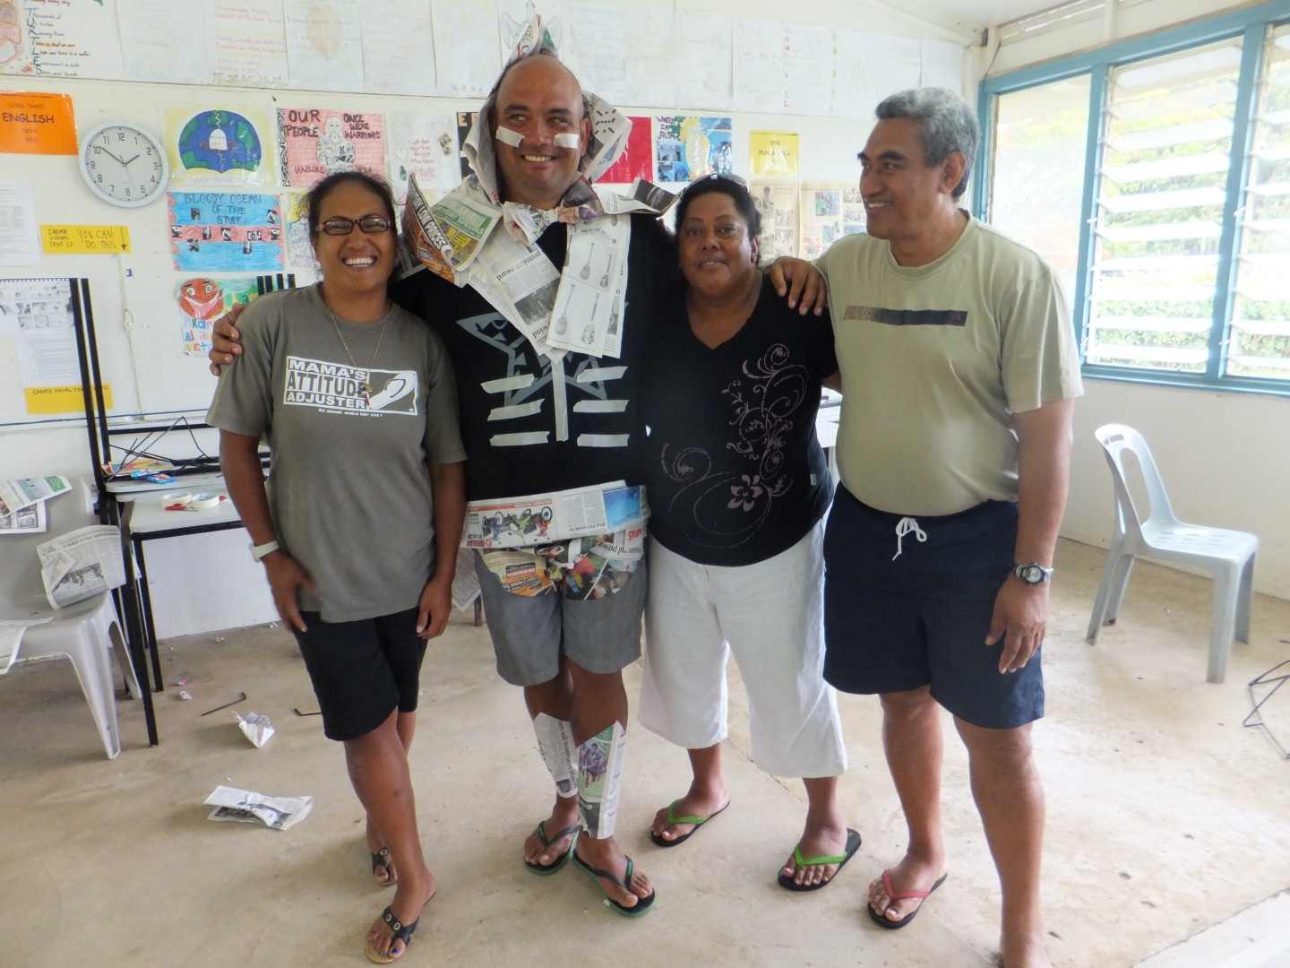
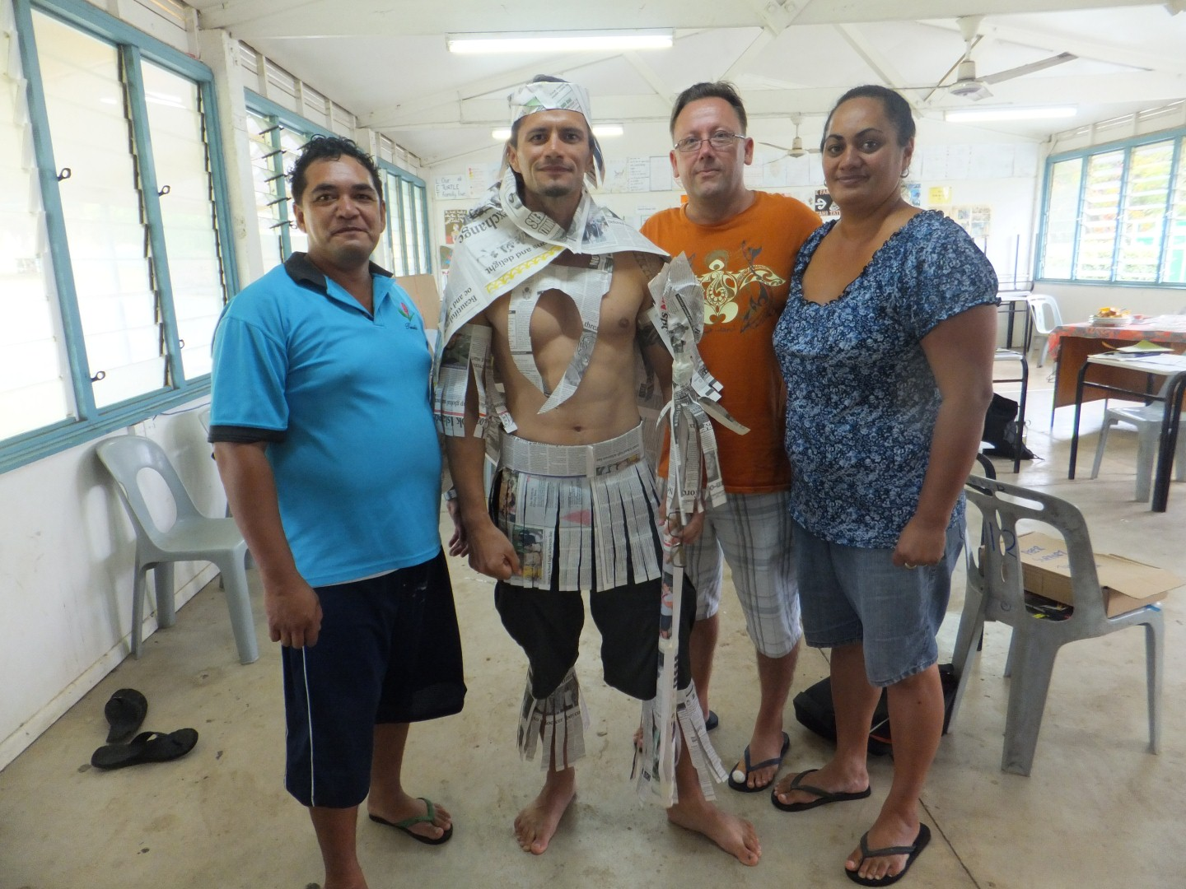

To order Peer Support resources go the website: www.peersupport.org.nz/resources

To contact us our mailing address is:
NZ Peer Support Trust
P O Box 6078
Upper Riccarton
Christchurch 8442

You can contact us by phone:
027 410 3325 or (03) 313 4971

Join our Facebook page at https://www.facebook.com/NzPeerSupportTrust?ref=hl
The NZ Peer Support Trust has been established by Rotary International to support the peer support programme in schools catering for the Years 7 to 13 in the New Zealand school system. The Trust comprises trustees appointed by the six Rotary districts within New Zealand. The trustees are responsible for overseeing the work of the Trust within New Zealand. The Trust is funded from the sales of its resources, particularly the manuals and from donations from Rotary clubs. The Peer Support Trust encourages schools to make contact with their local Rotary club to seek support for the purchase of manuals and other resources to help them with their programme.
September 2013
The Peer Support Programme In New Zealand

